Twins!



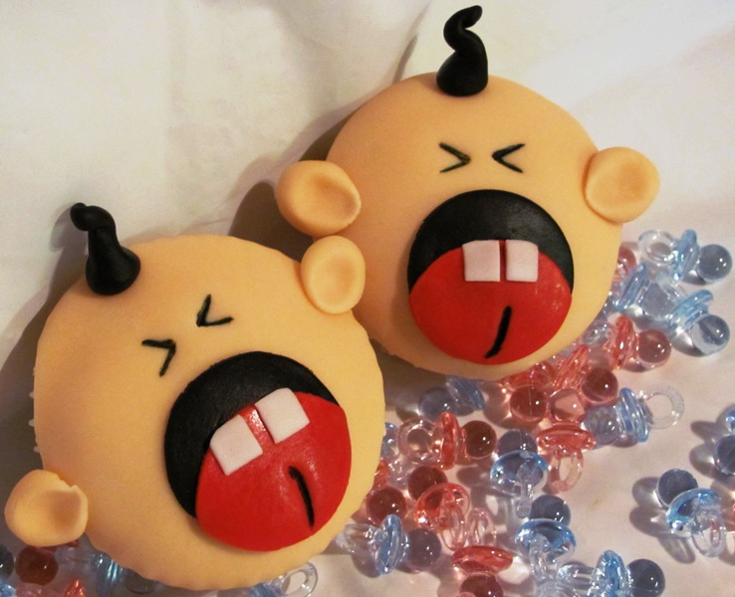

Cupcake Crafts

Free Cupcake Decorating Demo!

Saturday, April 30th, 2011

2:00-3:00PM

Barbs Pies & Pastries

1920 Main Street Ferndale WA 98242

(360) 312-8978

This "hands on" demonstration will teach you just how easy working with fondant is!

The only screams you'll hear for these tasty treats are "MORE!" And why stop at two?

There's enough supplies to decorate octuplets! Just right for a mom or dad with a

sense of humor or the highlight of your best friends baby shower, without the labor!

"Play with your Food!"

"Twins!" Cupcake Decorating Kits are $25.00. Each kit decorates 6-8 Cupcakes

Contact Kim at (360) 758-2306 for Details



www.cupcakecrafts4u.com