"We're Talking Turkey!"

Cupcake Decorating Classes

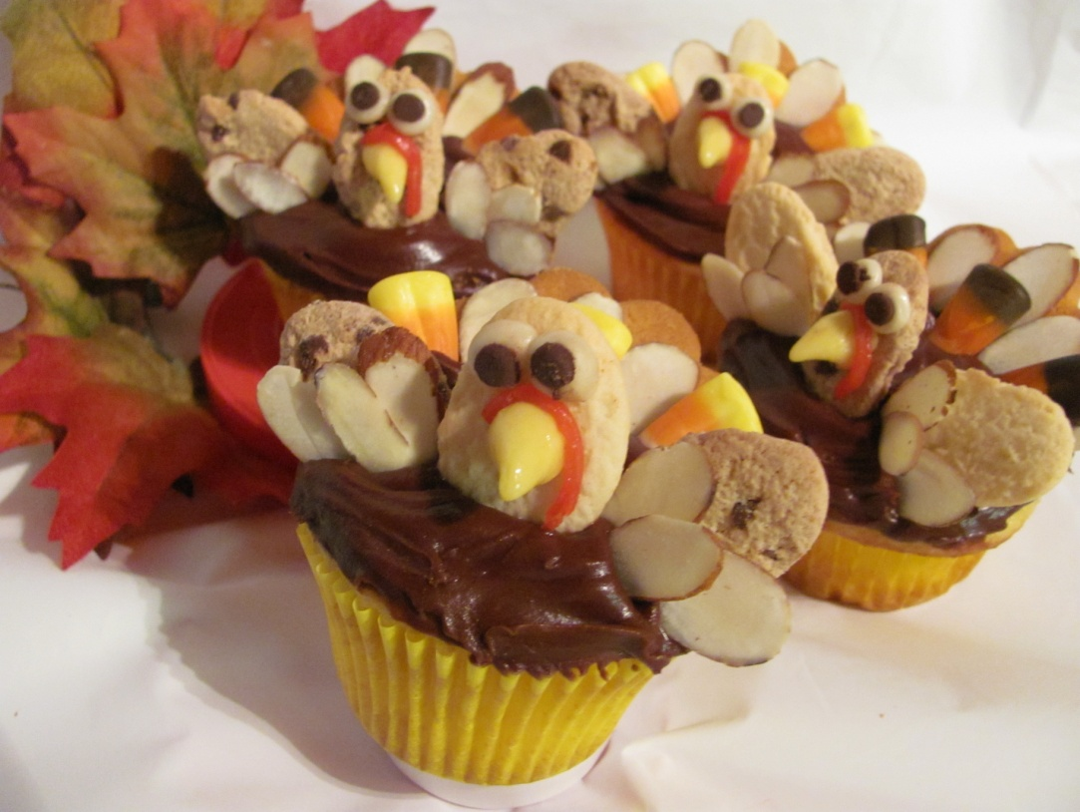

Sunday, November 21rst 2010

1:30-2:30PM or 3:30-4:30PM

Barbs Pies & Pastries

1920 Main Street Ferndale WA 98242

Class for 2 plus 2 Kits $40.00

Class for 1 plus 1 Kit $25.00

Class Only $10.00

All class supplies are provided

Learn how to make these whimsical birds, then take your kit home and

share a festive holiday activity with your friends & family!

Each kit decorates 12 Cupcakes

Take advantage of a 10% Discount on Pre-Ordered Cupcakes & Holiday Desserts

Contact Kim at (360) 758-2306 for Reservations



www.cupcakecrafts4u.com